**Scientific Project: Report 1**

We all can recognize the moment when you are studying but you can’t focus because of the noise of children playing or workers are renovating the street. The solution we want to apply is a smart automation system which will catch the sound waves from outside and it will generate an anti-sound wave so the annoying noise from outside will be reduced to 0. The circuit we will use in this project is an active noise cancellation circuit. It contains 3 parts: a non-inverting opamp for increasing the input signal of the microphone to get a usable amplitude, an inverting opamp for inverting the input signal to get rid of the noise at the output and a summing amplifier to combine the inverted signal of the noise with the sound you actually want to hear( music, silence, … etc). 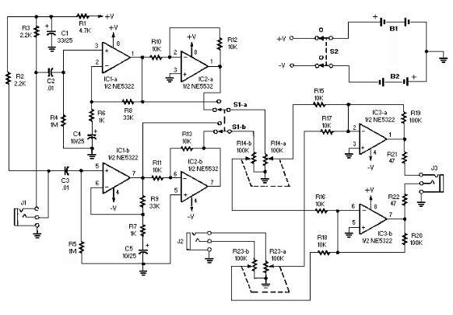

Ofcourse the input sensor will be a microphone and the output actuator will be an amplifier. The smart automation system can be expanded by adding the rooms temperature relay to control the rooms temperature. The output of the relay can either turn on a fan or a radiator. 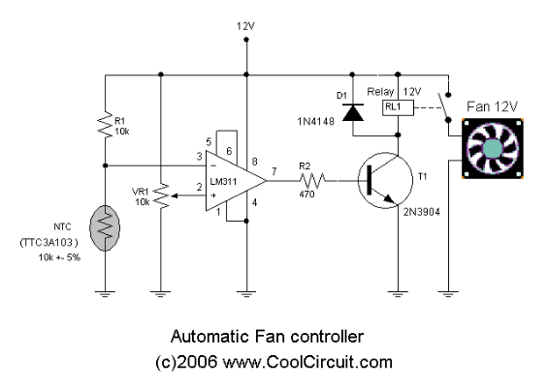 We can also add a carbon dioxide sensor to control the rooms ppm of carbon dioxide so that with high number ppm CO2 a window will open to release the CO2 outside. 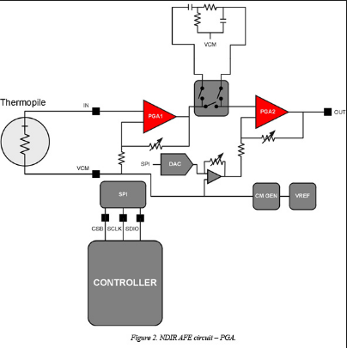

<http://www4.ncsu.edu/~rsmith/MA574_S15/silence.pdf>

Video about noice cancellation

<https://www.youtube.com/watch?v=o2s9a-60BIo>